Project Management Plan

**Document Control**

Document Information

|  |  |
| --- | --- |
| **©** | **Information** |
| Document Id | *[21026420]* |
| Document Owner | *[Rashed Hasan Qahah]* |
| Issue Date | *[4/11/2023]* |
| Last Saved Date | *[27/1/2024]* |
| File Name | *[Project Management Plan]* |

Document History

|  |  |  |
| --- | --- | --- |
| **Version** | **Issue Date** | **Changes** |
| *[1.0]* | *[Date]* | *[Section, Page(s) and Text Revised]* |
|  |  |  |
|  |  |  |
|  |  |  |

Document Approvals

|  |  |  |  |
| --- | --- | --- | --- |
| **Role** | **Name** | **Signature©** | **Date** |
| Project Sponsor |  |  |  |
| Project Review Group |  |  |  |
| Project Manager |  |  |  |
| Quality Manager  *(if applicable)* |  |  |  |
| Procurement Manager  *(if applicable)* |  |  |  |
| Communications Manager  *(if applicable)* |  |  |  |
| Project Office Manager  *(if applicable)* |  |  |  |

**Table of Contents**

Template Guide 1

1 Planning Basis 2

1.1 Scope 2

1.2 Milestones 2

1.3 Phases 2

1.4 Activities 3

1.5 Tasks 3

1.6 Effort 3

1.7 Resources 4

2 Project Plan 4

2.1 Schedule 4

2.2 Dependencies 5

2.3 Assumptions 5

2.4 Constraints 5

3 Appendix 5

# Template Guide

***What is a Project Plan?***

*The Project Plan is the central document by which the project is formally managed. A Project Plan is a document which lists the activities, tasks and resources required to complete the project and realise the business benefits outlined in the Project Business Case. A typical Project Plan includes:*

* *A description of the major phases undertaken to complete the project*
* *A schedule of the activities, tasks, durations, dependencies, resources and timeframes*
* *A listing of the assumptions and constraints identified during the planning process.*

*To create a Project Plan, the following steps are undertaken:*

* *Reiterate the project scope*
* *Identify the project milestones, phases, activities and tasks*
* *Quantify the effort required for each task*
* *Allocate project resource*
* *Construct a project schedule*
* *List any planning dependencies, assumptions, constraints*
* *Document the formal Project Plan for approval.*

***When to use a Project Plan***

*Although a summarised Project Plan is identified early in the Project Start-up Phase (within the Business Case), a detailed Project Plan is not usually created until the project scope has been formally defined (within a Project Charter) and the project team appointed. The Project Plan is completed early in the Project Planning Phase and is, typically, prior to a Quality Plan and the formalisation of a Supplier's contract. Unlike other documents in the Project Lifecycle, the Project Plan is referenced constantly throughout the project. As the project is undertaken, the Project Manager tracks the percentage of task completion and the task completion date (actual vs planned) to assess overall project performance. These statistics are communicated to the Project Sponsor/Board within a regular Project Status Report.*

***How to use this template***

*This document provides a guide on the topics usually included in a Project Plan. Sections may be added, removed or redefined at your leisure to meet your particular business circumstance. Example tables, diagrams and charts have been added (where suitable) to provide further guidance on how to complete each relevant section**.*

# 

# Planning Basis

## Scope

**Project title**: It is about implementing big data and IoT/AI technologies in hospitals for the maternity ward for real-time monitoring, data archiving and automation.

**Project scope statement:**

The aim of this project is to introduce and implement Big Data and IoT technologies within the maternity department of Irbid Specialist Hospital, Jordan, with the goal of enhancing real-time monitoring, data archiving, and automation features. The project aims to leverage these technologies to improve the efficiency, accuracy, and overall quality of maternity care services provided by the hospital.

**Project Requirements:**

* Integrate Big Data and IoT/AI technologies for real-time monitoring.
* Establish a robust data archiving system.
* Implement automation features for routine tasks.
* Ensure compliance with healthcare data security standards.

**The stakeholders:**

- Internal stakeholders:

- Maternity department staff (nurses, doctors, administrators)

- Hospital Information Technology Department

- Hospital administration and management

- External stakeholders:

- Technology vendors

- Regulatory authorities (healthcare compliance boards)

- Patients and their families

**Project Starting and Ending Dates:**

The project is going to begin on December 7th, 2023, and end on January 25th, 2024.

- Project start date: [7/11/2023]

- Project end date: [25/1/2024]

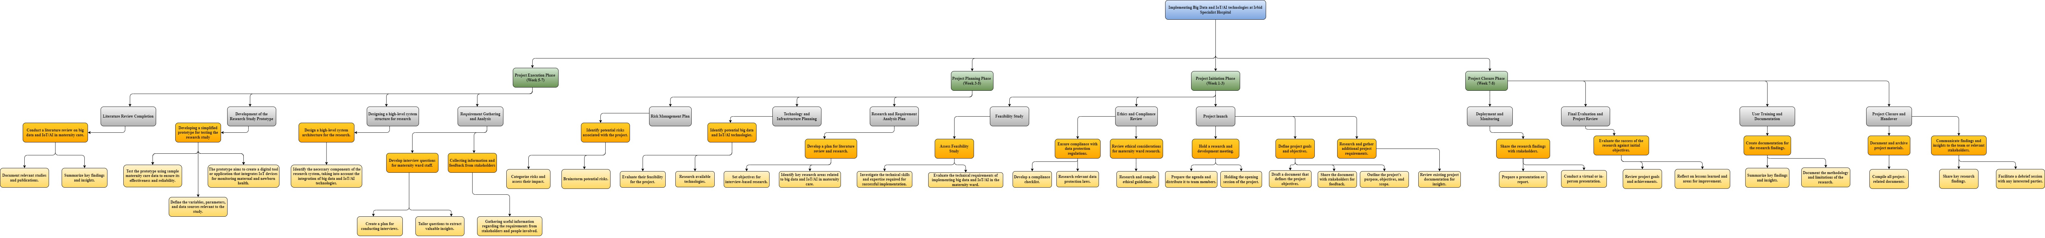

## Milestones

A *milestone* is “a major event in the project” and represents the completion of a set of activities. Examples of milestones include:

* Business Case approved
* Feasibility Study approved
* Project Charter approved
* Project Team appointed
* Project Office established.

List and describe the key project milestones within the following table:

|  |  |  |
| --- | --- | --- |
| **Milestone** | **Description** | **Delivery Date** |
| Project Launch. | The Project Launch milestone signifies the initiation of a research and development effort within TechKnow's R&D department. It involves a series of activities aimed at ensuring a clear understanding of the project's goals, objectives, and scope. | 13/12/2023 |
| The Ethics and Compliance Review. | The Ethics and Compliance Review milestone is a critical phase ensuring that the maternity ward research project adheres to rigorous ethical standards and complies with data protection regulations. | 16/12/2023 |
| Feasibility Study. | The Feasibility Study milestone is a critical phase where the viability of implementing Big Data and IoT/AI technologies in the maternity ward is thoroughly examined. This assessment includes an evaluation of technical requirements, potential challenges, and the necessary skills for successful implementation. | 21/12/2023 |
| Research and Requirement Analysis Plan. | The Research and Requirement Analysis Plan milestone focuses on planning the research activities and gathering requirements for the project. It sets the stage for comprehensive literature review and research. | 26/12/2023 |
| Technology and Infrastructure Planning Milestone. | The Technology and Infrastructure Planning milestone involves strategic planning to identify potential Big Data and IoT/AI technologies suitable for the maternity ward research. It aims to assess the feasibility of these technologies for effective implementation. | 30/12/2023 |
| Risk Management Plan. | The Risk Management Plan Milestone involves the identification and assessment of potential risks associated with the project. It aims to develop a comprehensive plan to mitigate and manage these risks effectively throughout the project lifecycle. | 4/1/2024 |
| Requirement Gathering and Analysis. | The Requirement Gathering and Analysis milestone marks the phase where the research team actively engages in collecting and analysing requirements for the maternity ward research project. This milestone is crucial for shaping the direction of the research effort. | 7/1/2024 |
| Designing a high-level system structure for research. | The System Design and Architecture milestone represent a crucial phase in the project, focusing on the development of a high-level structure for the research system. It involves defining the necessary components to support the objectives of the project. | 8/1/2024 |
| Development of the Research Study Prototype. | The Development of the Research Study Prototype milestone signifies the creation of a simplified prototype for testing, specifically designed for maternity ward research utilizing Big Data and IoT/AI technologies. | 14/1/2024 |
| Literature Review Completion | The Literature Review Completion milestone signifies the culmination of the research phase dedicated to reviewing existing literature on big data and IoT/AI in maternity care. It involves summarizing key findings, documenting relevant studies, and drawing insights to inform the project. | 18/1/2024 |
| Deployment and Monitoring. | The Deployment and Monitoring milestone represents the final phase of the project, where the research findings are shared with stakeholders, and the project's success is evaluated against initial objectives. It involves activities related to presenting the research results, evaluating success, documenting findings, and communicating insights to the relevant parties. | 21/1/2024 |
| Final Evaluation and Project Review. | The Final Evaluation and Project Review milestone represent the conclusion of the research project. It involves a comprehensive assessment of the project's success against its initial objectives, a reflection on lessons learned, and the creation of documentation to capture key findings. | 22/1/2024 |
| User Training and Documentation | The User Training and Documentation milestone marks the final stages of the project, focusing on creating documentation for research findings and providing training to relevant stakeholders. | 23/1/2024 |
| Project Closure and Handover. | The Project Closure and Handover milestone represent the culmination of the research project. It involves the completion of key activities to ensure a smooth closure, comprehensive documentation, and effective communication of findings and insights to relevant stakeholders. | 25/1/2024 |

## Phases

A *phase* is “a set of activities which will be undertaken to deliver a substantial portion of the overall project”. Examples include:

* Project Initiation
* Project Planning
* Project Execution
* Project Closure.

List and describe the major project phases within the following table.

|  |  |  |
| --- | --- | --- |
| **Phase** | **Description©** | **Sequence** |
| Project Initiation | The Project Initiation Phase marks the commencement of the research and development initiative focused on enhancing maternity care through the application of Big Data and IoT/AI technologies. This phase is critical for setting the groundwork, defining project objectives, and ensuring ethical considerations and compliance with regulations. | Phase # 1 |
| Project Planning Phase | The Project Planning Phase follows the initiation phase, focusing on the detailed planning required for the successful implementation of the research project aimed at incorporating Big Data and IoT/AI technologies into maternity care. This phase involves key milestones, each addressing critical aspects of the project. | Phase # 2 |
| Project Execution  Phase | The Project Execution Phase represents the stage where the actual work of the research project is carried out. It involves implementing the plans and strategies outlined in the Project Planning Phase, focusing on achieving the established project objectives. | Phase # 3 |
| Project Closure Phase | The Project Closure Phase marks the final stage of the project life cycle, where activities focus on wrapping up the project, evaluating its success, and disseminating key findings and proper documentation. | Phase # 4 |

## Activities

An *activity* is “a set of tasks which are required to be undertaken to complete the project." Examples include:

* Develop Quality Plan
* Formulate Supplier Contracts
* Perform Project Closure.

List and describe the major project activities within the following table.

|  |  |  |  |
| --- | --- | --- | --- |
| **Phase** | **Activity** | **Description©** | **Sequence** |
| **Project Initiation** | **Hold a Research and Development Meeting.** | The Research and Development meeting serves as the official launch of the project, bringing together key stakeholders to discuss the project's objectives, scope, and initial plans. | **Hold a Research and Development Meeting before the Define Project Goals and Objectives.** |
| **Project Initiation** | **Define Project Goals and Objectives.** | This activity involves defining the overarching goals, specific objectives, and the overall scope of the project. It sets the foundation for subsequent project planning. | After the Hold a Research and Development Meeting but before the Research and Gather Additional Project Requirements. |
| **Project Initiation** | **Research and Gather Additional Project Requirements.** | Beyond the initial project scope, this task involves reviewing existing documentation and collecting any additional requirements to ensure a comprehensive understanding of the project. | After the **Define Project Goals and Objectives** but before the **Review of Ethical Considerations for Maternity Ward Research.** |
| **Project Initiation** | **Review of Ethical Considerations for Maternity Ward Research.** | This activity delves into the ethical considerations related to conducting research in the maternity ward, ensuring that the project aligns with ethical guidelines. | After the **Research and Gather Additional Project Requirements** but before the **Feasibility Study Evaluation.** |
| **Project Initiation** | **Ensure compliance with data protection regulations.** | Following the ethical review, this activity ensures that the project adheres to data protection regulations, safeguarding sensitive information. | After the **Research and Gather Additional Project Requirements** but before the Assess Feasibility Study. |
| **Project Initiation** | Assess Feasibility Study. | This critical activity evaluates the technical requirements for implementing Big Data and IoT/AI in the maternity ward, addressing the project's feasibility. | After the **Ensure compliance with data protection regulations.** |
| **Project Planning** | **Develop a Plan for Literature Review and Research.** | This activity involves creating a plan for the literature review and research phase, identifying key research areas related to big data and IoT/AI in maternity care. | **Develop a Plan for Literature Review and Research before Identify Potential Big Data and IoT/AI Technologies.** |
| **Project Planning** | **Identify Potential Big Data and IoT/AI Technologies.** | This crucial activity focuses on researching available technologies, evaluating their feasibility for the project, and selecting the most suitable ones. | After the **Develop a Plan for Literature Review and Research** but before the **Identify Potential Risks Associated with the Project.** |
| **Project Planning** | **Identify Potential Risks Associated with the Project.** | This activity involves brainstorming potential risks, categorizing them, and assessing their impact to develop a comprehensive risk management plan. | After the **Identify Potential Big Data and IoT/AI Technologies.** |
| **Project Execution** | **Collecting information and feedback from stakeholders.** | This activity involves the systematic collection of pertinent information and feedback from key stakeholders and individuals associated with the project. The aim is to engage with these parties to understand their perspectives, expectations, and specific requirements. | **Collecting information and feedback from stakeholders before the Develop Interview Questions for Maternity Ward Staff.** |
| **Project Execution** | **Develop Interview Questions for Maternity Ward Staff.** | This activity is essential for the data collection process, requiring the development of targeted interview questions for maternity ward staff. | **After Collecting information and feedback from stakeholders. Before the Design a High-Level System Architecture for the Research.** |
| **Project Execution** | **Design a High-Level System Architecture for the Research.** | The high-level system architecture for healthcare research plays a pivotal role in enabling the effective application of Big Data and IoT/AI technologies. This phase involves outlining the overall structure, components, and interactions within the research system. | After the **Develop Interview Questions for Maternity Ward Staff** but before the **Develop a Simplified Prototype for Testing.** |
| **Project Execution** | **Developing a simplified prototype for testing the research study.** | In the context of researching the application of Big Data and IoT/AI in medicine and healthcare, the Prototype Development milestone focuses on creating a simplified prototype for testing key functionalities and assessing the feasibility of the research study. | After the **Design a High-Level System Architecture for the Research** but before the **Conduct a Literature Review on Big Data and IoT/AI in Maternity Care.** |
| **Project Execution** | **Conduct a Literature Review on Big Data and IoT/AI in Maternity Care.** | This academic activity focuses on summarizing key findings and insights from existing literature on big data and IoT/AI in maternity care. | After the **Develop a Simplified Prototype for Testing.** |
| **Project Closure** | **Share Research Findings with Stakeholders.** | This activity involves preparing a presentation or report and conducting a virtual or in-person presentation to share the research findings with stakeholders. | **Share Research Findings with Stakeholders before the Evaluate the Success of the Research Against Initial Objectives.** |
| **Project Closure** | **Evaluate the Success of the Research Against Initial Objectives.** | This reflective activity involves reviewing project goals and achievements, reflecting on lessons learned, and identifying areas for improvement. | After the **Share Research Findings with Stakeholders** but before create Documentation for the Research Findings. |
| **Project Closure** | **Create Documentation for the Research Findings.** | This documentation-focused activity involves summarizing key findings and insights and documenting the methodology and limitations of the research. | After the **Evaluate the Success of the Research Against Initial Objectives** but before Document and Archive Project Materials. |
| **Project Closure** | **Document and Archive Project Materials.** | This administrative activity involves compiling all project-related documents and ensuring that they are appropriately archived for future reference. | After the **Create Documentation for the Research Findings** but before Communicate Findings and Insights to the Team or Relevant Stakeholders. |
| **Project Closure** | **Communicate Findings and Insights to the Team or Relevant Stakeholders.** | This concluding activity involves sharing key research findings and facilitating a debrief session with any interested parties. | After the **Document and Archive Project Materials.** |

## Tasks

A ‘*task*’ is simply an item of work to be completed within the project. List all tasks required to undertake each activity, within the following table:

|  |  |  |  |
| --- | --- | --- | --- |
| **Phase** | **Activity** | **Task** | **Sequence** |
| **Project Initiation** | **Hold a Research and Development Meeting.** | * Holding the opening session of the project. * Prepare the agenda and distribute it to team members. | 1st  2nd |
| **Project Initiation** | **Define Project Goals and Objectives.** | * Drafting a document defining the project objectives. * Share the document with stakeholders to get feedback. * Outline the project’s goal, objectives, and scope. | 1st  2nd  3rd |
| **Project Initiation** | **Research and Gather Additional Project Requirements.** | * Review current project documentation to gain insights. | 1st |
| **Project Initiation** | **Review of Ethical Considerations for Maternity Ward Research.** | * Research and compile ethical guidelines. | 1st |
| **Project Initiation** | **Ensure compliance with data protection regulations.** | * Develop a compliance checklist. * Research relevant data protection laws. | 1st  2nd |
| **Project Initiation** | **Assess Feasibility Study.** | * Evaluate the technical requirements for implementing Big Data and IoT/AI in the maternity ward. * Investigate the technical skills and experience necessary for successful implementation. | 1st  2nd |
| **Project Planning** | **Develop a Plan for Literature Review and Research.** | * Identify key research areas related to big data and IoT/AI in maternity care. * Set objectives for interview-based research. | 1st  2nd |
| **Project Planning** | **Identify Potential Big Data and IoT/AI Technologies.** | * Research available technologies. * Evaluate their feasibility for the project. | 1st  2nd |
| **Project Planning** | **Identify Potential Risks Associated with the Project.** | * ­Brainstorm potential risks. * Categorize risks and assess their impact. | 1st  2nd |
| **Project Execution** | **Collecting information and feedback from stakeholders.** | * **Collecting information and feedback from stakeholders before the Develop Interview Questions for Maternity Ward Staff.** | 1st |
| **Project Execution** | **Develop Interview Questions for Maternity Ward Staff.** | * Tailor questions to extract valuable insights. * Create a plan for conducting interviews. | 1st  2nd |
| **Project Execution** | **Design a High-Level System Architecture for the Research.** | * Identify the necessary components of the research system, taking into account the integration of big data and IoT/AI technologies. | 1st |
| **Project Execution** | **Developing a simplified prototype for testing the research study.** | * The prototype aims to create a digital tool or application that integrates IoT devices for monitoring maternal and newborn health. * Test the prototype using sample maternity care data to ensure its effectiveness and reliability. * Define the variables, parameters, and data sources relevant to the study. | 1st  2nd  3rd |
| **Project Execution** | **Conduct a Literature Review on Big Data and IoT/AI in Maternity Care.** | * Summarize key findings and insights. * Document relevant studies and publications. | 1st  2nd |
| **Project Closure** | **Share Research Findings with Stakeholders.** | * Prepare a presentation or report. * Conduct a virtual or in-person presentation. | 1st  2nd |
| **Project Closure** | **Evaluate the Success of the Research Against Initial Objectives.** | * Review project goals and achievements. * Reflect on lessons learned and areas for improvement. | 1st  2nd |
| **Project Closure** | **Create Documentation for the Research Findings.** | * Summarize key findings and insights. * Document the methodology and limitations of the research. | 1st  2nd |
| **Project Closure** | **Document and Archive Project Materials.** | * Compile all project-related documents. | 1st |
| **Project Closure** | **Communicate Findings and Insights to the Team or Relevant Stakeholders.** | * Share key research findings. * Facilitate a debrief session with any interested parties. | 1st  2nd |

## Effort

For each task listed above, quantify the likely ‘effort’ required to complete the task.

|  |  |
| --- | --- |
| **Task©** | **Effort** |
| * Holding the opening session of the project. * Prepare the agenda and distribute it to team members. | *1 day*  *1 day* |
| * Drafting a document defining the project objectives. * Share the document with stakeholders to get feedback. * Outline the project’s goal, objectives, and scope. | *1 day*  *1 day*  *1 day* |
| * Review current project documentation to gain insights. | *1 day* |
| * Research and compile ethical guidelines. | *1 day* |
| * Research relevant data protection laws. * Develop a compliance checklist. | *1 day*  *1 day* |
| * Evaluate the technical requirements for implementing Big Data and IoT/AI in the maternity ward. * Investigate the technical skills and experience necessary for successful implementation. | *2 days*  *3 days* |
| * Identify key research areas related to big data and IoT/AI in maternity care. * Set objectives for interview-based research. | *2 days*  *2 days* |
| * Research available technologies. * Evaluate their feasibility for the project. | *2 days*  *2 days* |
| * ­Brainstorm potential risks. * Categorize risks and assess their impact. | *2 days*  *3 days* |
| * **Collecting information and feedback from stakeholders before the Develop Interview Questions for Maternity Ward Staff.** | *1 day* |
| * Tailor questions to extract valuable insights. * Create a plan for conducting interviews. | *1 day*  *1 day* |
| * Identify the necessary components of the research system, taking into account the integration of big data and IoT/AI technologies. | *1 day* |
| * The prototype aims to create a digital tool or application that integrates IoT devices for monitoring maternal and newborn health. * Test the prototype using sample maternity care data to ensure its effectiveness and reliability. * Define the variables, parameters, and data sources relevant to the study. | *2 days*  *2 days*  *2 days* |
| * Summarize key findings and insights. * Document relevant studies and publications. | *2 days*  *2 days* |
| * Prepare a presentation or report. * Conduct a virtual or in-person presentation. | *2 days*  *2 days* |
| * Review project goals and achievements. * Reflect on lessons learned and areas for improvement. | *1 day*  *1 day* |
| * Summarize key findings and insights. * Document the methodology and limitations of the research. | *1 day*  *1 day* |
| * Compile all project-related documents. | *1 day* |
| * Share key research findings. * Facilitate a debrief session with any interested parties. | *1 day*  *1 day* |

## Resources

For each task identified, list the resources allocated to complete the task.

|  |  |
| --- | --- |
| **Task©** | **Resource** |
| * Holding the opening session of the project. * Prepare the agenda and distribute it to team members. | *Facilitator*  *Coordinator* |
| * Drafting a document defining the project objectives. * Share the document with stakeholders to get feedback. * Outline the project’s goal, objectives, and scope. | *Project Coordinator*  *Project Manager*  *Project Manager* |
| * Review current project documentation to gain insights. | *Project Team Members* |
| * Research and compile ethical guidelines. | *Ethics Specialist and Researcher* |
| * Evaluate the technical requirements for implementing Big Data and IoT/AI in the maternity ward. * Investigate the technical skills and experience necessary for successful implementation. | *Researcher and IT Specialist*  *Human Resources and Technical Expert* |
| * Identify key research areas related to big data and IoT/AI in maternity care. * Set objectives for interview-based research. | *Researcher and Big data/AI &IoT Matter Expert*  *Researcher and Stakeholders* |
| * Research available technologies. * Evaluate their feasibility for the project. | *Technology Technical Analyst and Researcher*  *Project idea researcher (Book-* *Articles (and technology analyst* |
| * ­Brainstorm potential risks. * Categorize risks and assess their impact. | *Project Team Members*  *Risk Management Specialist* |
| * Gathering useful information regarding the requirements from stakeholders and people involved. | *Project Team Members*  *Coordinator*  *Researcher and Stakeholders* |
| * Tailor questions to extract valuable insights. * Create a plan for conducting interviews. | *Researcher and Project Manager*    *Project Manager* |
| * Identify the necessary components of the research system, taking into account the integration of big data and IoT/AI technologies. | *Technical Expert and System Architect* |
| * The prototype aims to create a digital tool or application that integrates IoT devices for monitoring maternal and newborn health. * Test the prototype using sample maternity care data to ensure its effectiveness and reliability. * Define the variables, parameters, and data sources relevant to the study. | *Development Team*  *Testing Team*  *Data Analyst Researcher* |
| * Summarize key findings and insights. * Document relevant studies and publications. | *Project Coordinator*  *Documentation Specialist* |
| * Prepare a presentation or report. * Conduct a virtual or in-person presentation. | *Project Manager Project Coordinator* |
| * Review project goals and achievements. * Reflect on lessons learned and areas for improvement. | *Project Team*  *Project Team Members* |
| * Summarize key findings and insights. * Document the methodology and limitations of the research. | *Researcher and Project Coordinator* |
| * Compile all project-related documents. | *Documentation Specialist* |
| * Share key research findings. * Facilitate a debrief session with any interested parties. | *Project Manager and Facilitator* |

# Project Plan

## Schedule

Provide a summarised schedule for each of the phases and activities within the project.

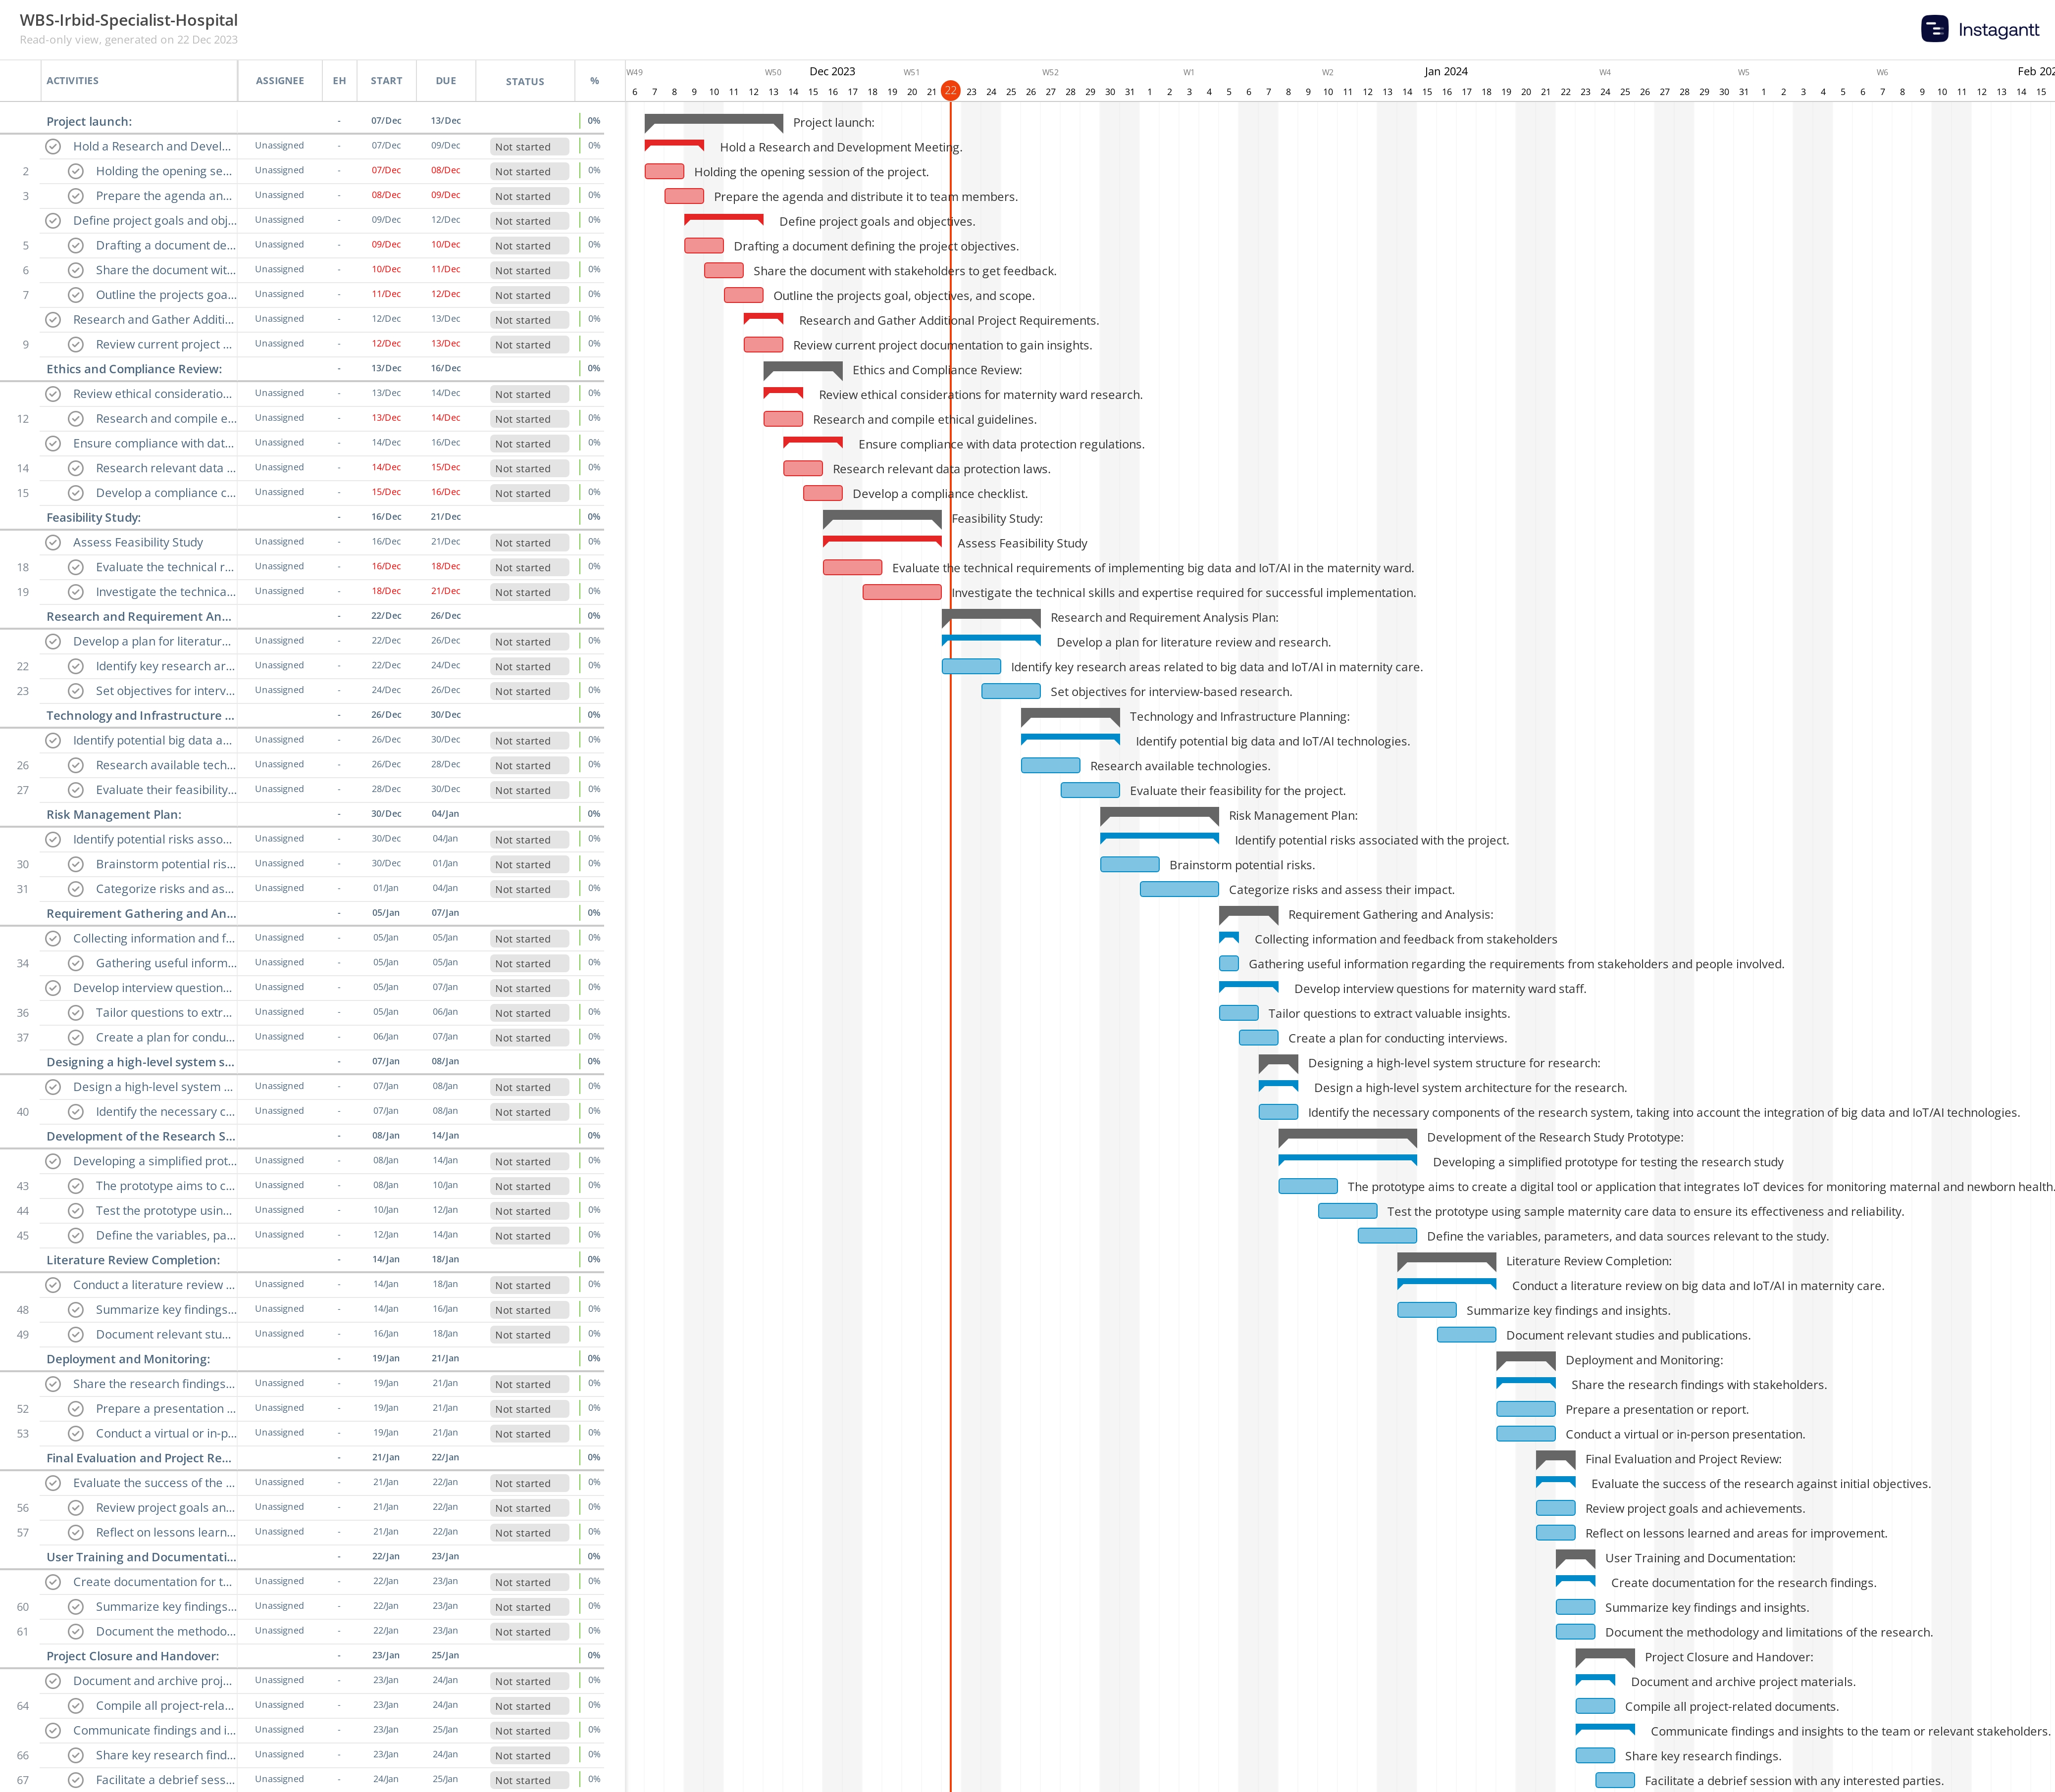

Note: Refer to the Appendix for a detailed project schedule.

## Dependencies

‘Dependencies’ are logical relationships between phases, activities or tasks which influence the way that the project must be undertaken. Dependencies may be either internal to the project (e.g. between project activities) or external to the project (e.g. a dependency between a project activity and a business activity). There are four types of dependencies:

1. Finish-to-start *(the item this activity depends on must finish before this activity can start)*
2. Finish-to-finish *(the item this activity depends on must finish before this activity can finish)*
3. Start-to-start *(the item this activity depends on must start before this activity can start)*
4. Start-to-finish *(the item this activity depends on must start before this activity can finish).*

List any key project dependencies identified by completing the following table:

|  |  |  |
| --- | --- | --- |
| **Activity** | **Depends on©** | **Dependency Type** |
| Hold a Research and Development Meeting | None | None |
| Define Project Goals and Objectives | Hold a Research and Development Meeting | Finish-to-start |
| Research and Gather Additional Project Requirements | Define Project Goals and Objectives | Finish-to-start |
| Review of Ethical Considerations for Maternity Ward Research | Hold a Research and Development Meeting | Finish-to-start |
| Ensure compliance with data protection regulations | Review of Ethical Considerations | Finish-to-start |
| Assess Feasibility Study | Review of Ethical Considerations | Finish-to-start |
| Develop a Plan for Literature Review and Research | Define Project Goals and Objectives | Finish-to-start |
| Identify Potential Big Data and IoT/AI Technologies | Assess Feasibility Study | Finish-to-start |
| Identify Potential Risks Associated with the Project | Assess Feasibility Study | Finish-to-start |
| Collecting information and feedback from stakeholders. | Research and Gather Additional Project Requirements and Assess Feasibility Study. | Finish-to-start |
| Develop Interview Questions for Maternity Ward Staff | Define Project Goals and Objectives | Finish-to-start |
| Design a High-Level System Architecture for the Research | Identify Potential Big Data and IoT/AI Technologies | Finish-to-start |
| Developing a simplified prototype for testing the research study | Design a High-Level System Architecture | Start-to-start |
| Conduct a Literature Review on Big Data and IoT/AI in Maternity Care | Develop a Plan for Literature Review | Finish-to-start |
| Share Research Findings with Stakeholders | Conduct a Literature Review | Finish-to-start |
| Evaluate the Success of the Research Against Initial Objectives | Share Research Findings with Stakeholders | Finish-to-start |
| Create Documentation for the Research Findings | Evaluate the Success of the Research | Start-to-finish |
| Document and Archive Project Materials | Create Documentation for the Research Findings | Finish-to-start |
| Communicate Findings and Insights to the Team or Relevant Stakeholders | Share Research Findings with Stakeholders | Finish-to-start |

In the example given above, the activity” Appoint Project Team” must finish before activity “Set-up Project Office” can start.

## Assumptions

List any planning assumptions made. For example:

It is assumed that:

* The project will not change in scope
* The resources identified will be available upon request
* Approved funding will be available upon request.

## Constraints

List any planning constraints identified. For example:

* The project must operate within the funding and resource allocations approved
* The project team must deliver the software with no requirement for additional hardware
* Staff must complete the project within normal working hours.

# 

# Appendix

Attach any documentation you believe is relevant to the Project Plan. For example:

* Detailed Project Schedule (listing all project phases, activities and tasks)
* Other documentation (Business Case, Feasibility Study, Project Charter)
* Other relevant information or correspondence.